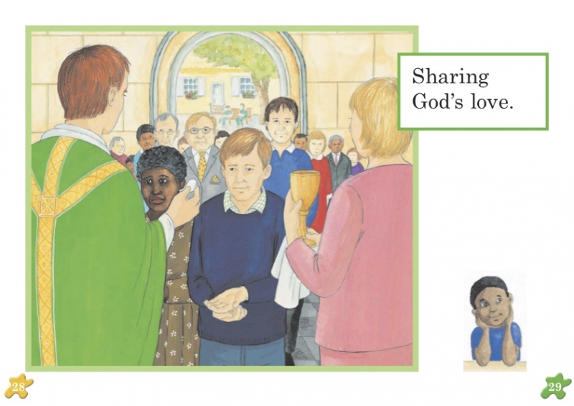
- What do you see in the picture? (Priest, people, Extraordinary Minister of Holy Communion, Chalice)
- What is happening? (The priest giving the host, Extraordinary Minister of Holy Communion giving the chalice)
- What do people do who do not receive Holy Communion? (cross arms against their chest and receive a blessing)

