Thursday 25th February 2021
Can I make a model of the Mars surface and evaluate it?
This week something very exciting has happened in the world of Space science.
"Touchdown confirmed" - there is a new robot on Mars!
This video is an animation of how scientists planned the landing, not footage of the real thing, but it gives a really good idea of the successful landing.
https://www.youtube.com/watch?v=rzmd7RouGrM&safe=active
Read about Perseverance and its mission here:
https://spaceplace.nasa.gov/mars-2020/en/
Amazing, isn’t it?!
When scientists are working together in big teams to plan missions like this, they have to model their experiments on Earth before they try and perform them in space. Why do you think they do this?
We’re going to try and model the surface of Mars. To do this, you will need a flat baking tray, some flour of any kind and some cocoa powder.
First let’s compare the surfaces of the Moon and Mars. (The last manned mission to the Moon was Apollo 17, taking place between 7 and 19 December 1972. 12 astronauts have walked on the moon in total. We have pictures of the surface and moon rock samples.)
Here’s a close up photo of the Moon’s surface. Here’s the surface of Mars.
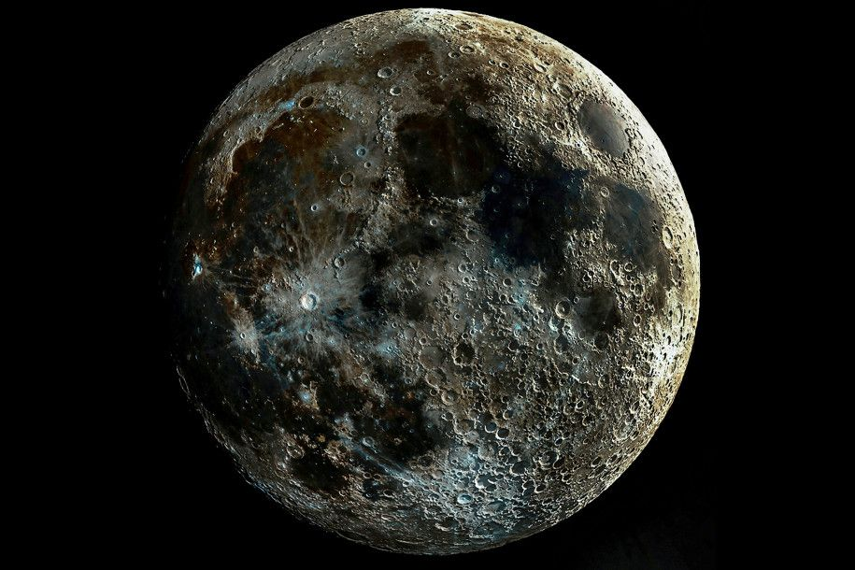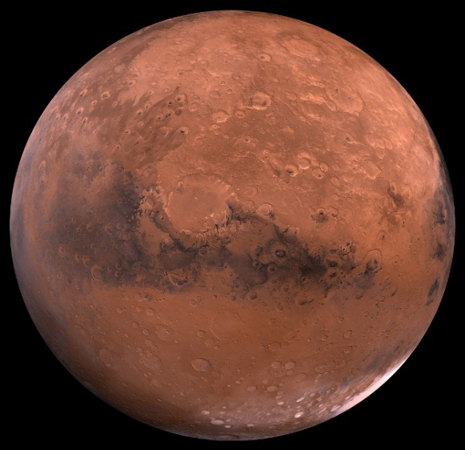
You could have a look for some more images online too. What is the same about them? What is different? What do you think the round holes are?
They ae actually craters made by meteorite impacts over billions of years. Meteorites are pieces of rock from outer space that have crashed onto the surface of planets and moons, causing these round ‘holes’.
Can you make a ‘fake’ photo of the surface of Mars? Spread some flour about 1cm deep onto your baking tray. Try dropping missiles onto the surface to make craters. You can shake the flour in between each try to ‘reset’ the flour. What kind of meteorite makes the deepest crater? Which makes the widest crater? Try dropping your meteorites from a greater height. Are the craters the same as before, deeper or not so deep? Is there a link between the size of the meteorite and how wide and deep the crater is? Is there a link between the weight of the meteorite and the width and depth of the hole made?
If you take black and white photos of your surfaces and avoid getting the edge of the tray in the picture, it should look like the surface of a planet.
Once you’ve experimented a bit, decide which meteorites make the most convincing looking surface. Now sprinkle a thin layer of cocoa powder onto your ‘reset’ flour. This will provide contrast and make the photo look even better. Blast your surface with your chosen meteorites and take a black and white photo. It should look very like a planet surface. Do you need to add anything else to make it look even more like the surface of Mars?
Please upload your final photo to seesaw. I’d love to add them to our photo collage in school. I’ll make a photo model of the planet Mars and show you all.
In your book, write the date Thursday 25th February 2021
and learning objective Can I make a model of the Mars surface and evaluate it?
Write a short introduction about why you have done this activity. You could use some or all of these words:
Mars Perseverance rover signs of life landed craters meteorites surface February 18th 2021
Describe how you made your model of the surface.
Stick a copy of the final photo in or draw your surface.
Evaluation How good a model have you made? Does it look very like Mars or a bit like it or nothing like the real thing? How could you improve it?
Finally, can you explain why scientists sometimes use models to carry out experiments?
The underlined words/phrases can be used as your subheadings.
Well done! I look forward to seeing your photos.

