Wednesday 24th February 2021
Can I write a letter in the role of a character?
Starter
What is a character? Try and discuss this questions with an adult.
Who wrote the letters? Who did they write to? Why did they write to Duncan?
What would you say or do if the crayons were writing to you?
Main Task
Today you are going to pretend that you are Duncan. You will need to write a letter and respond to Blue Crayon’s concerns and worries.
How do you think Duncan would reply to the letters?
What would he say to make them want to come back?
Read the letter sent to Duncan from Blue Crayon (this may be clearer by reading the letter on the PowerPoint presentation).
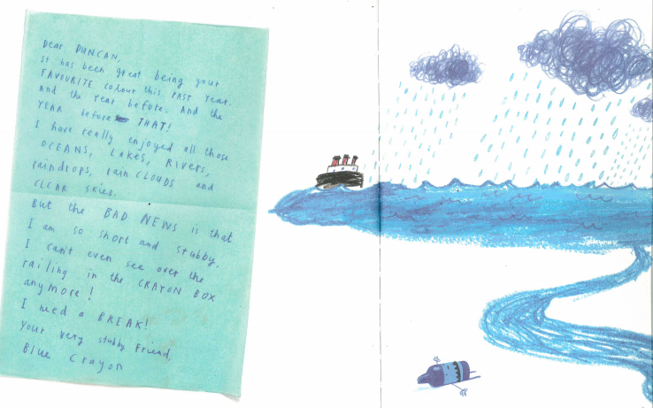
How would we begin the letter? Would Duncan apologise?
Why was blue crayon upset? (because he was too short and stubby)
What could Duncan do to resolve the problem?
Try to create a mind map with all you different solutions to the problem. What do you think would happen if Duncan replaced the blue crayon?
E.g. Only use Blue Crayon for small rain drops
Solutions to the problem.

E.g. Replace Blue Crayon with light Blue Crayon

Key Questions:
• Why is the crayon upset?
• What would Duncan say to make the crayon comeback?
• How would he solve the problem?
• Would he say sorry?
Here is an example of how you could start your letter:
Dearest friend,
Thank you for your letter Blue Crayon. Everything you draw makes me happy and you are one of my favourite crayons. Can you imagine using red Crayon to colour in the sea? I would be lost without you. I can understand why you are upset; however, you should be grateful that I use you. I don’t even bother with Light Blue Crayon so you should consider yourself lucky. You are my favourite crayon so please do not quit. I need you when I want to draw oceans, lakes and rivers. I know you are short and stubby but I promise I will…
Success criteria
- Make sure to use capital letters and the correct punctuation
- Produce beautiful handwriting with lead-ins to every letter
- Read Blue Crayon’s letter carefully. How are they feeling? How will you resolve the problem?
- Use first person
- Try to write at least half a page
Read your letter to a parent. Can you spot any mistakes/errors? Can you make any improvements?

