Tuesday 23rd February 2021
Can I write a diary entry, predicting what will happen next?
Starter
Can you remember the story from yesterday? What did the crayons do? Why do you think the crayons wanted to quit?
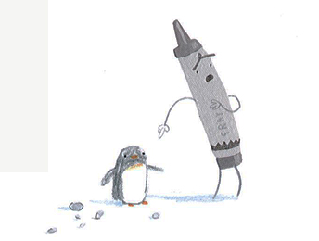
What would the crayons do instead?
Where do you think the crayons would go?
What would they do?
Would they go together?
Yesterday we read up to Grey Crayon’s letter. Today, read as far as Green Crayon’s letter.
Main Task
Look at the pictures of different settings/activities and discuss whether the crayons might do these activities.
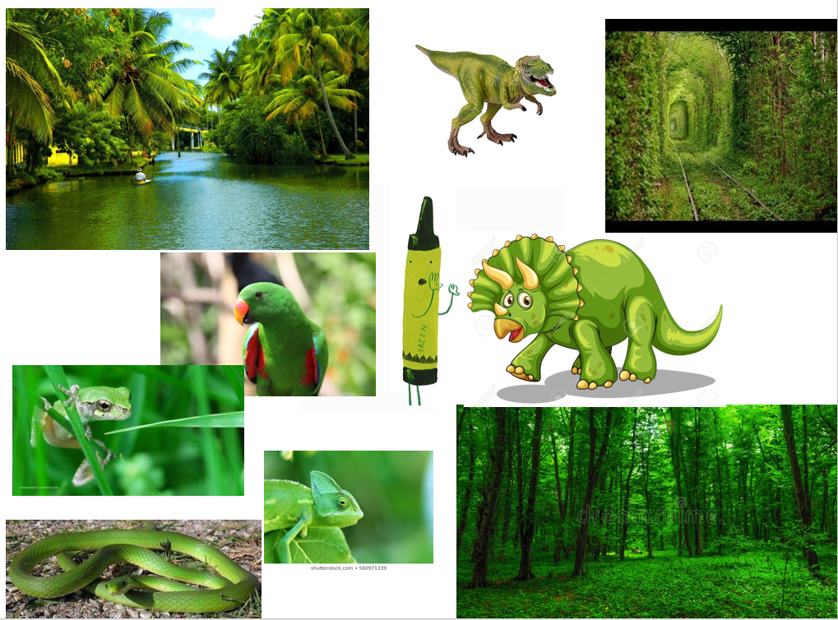
Would red crayon go to London and visit all the red buses/phone boxes/post boxes? Or visit Father Christmas?
Would green crayon visit all the forests, fields and dragons?
Today we are going to imagine we are one crayon (any colour) and we are going to write a diary of what has happened since we quit our job as a crayon.
Here are some questions to help you structure your diary:
• Where have you been?
• What have you been doing?
• How do you feel?
• Do you miss the other crayons/Duncan? Why/why not?
Here is a short example:
Dear Diary,
It’s Red Crayon here. I am currently in London looking at all the red buses and post boxes. I’m glad I don’t have to colour those. That would take me forever! Duncan used to make me work so hard, especially through the holidays. Now it’s time for me to relax and think about myself. However, it is very busy here and people keep nearly stepping on me. Maybe I should go back home. I do miss Duncan and he did love to use me on nearly every piece of work. I miss my friend, Pink Crayon. What have I done? I want to go home!
Success criteria
- Make sure to use capital letters and the correct punctuation
- Produce beautiful handwriting with lead-ins to every letter
- Decide on a colour crayon
- Think about what the crayon might have been up to since quitting
- Write in first person

