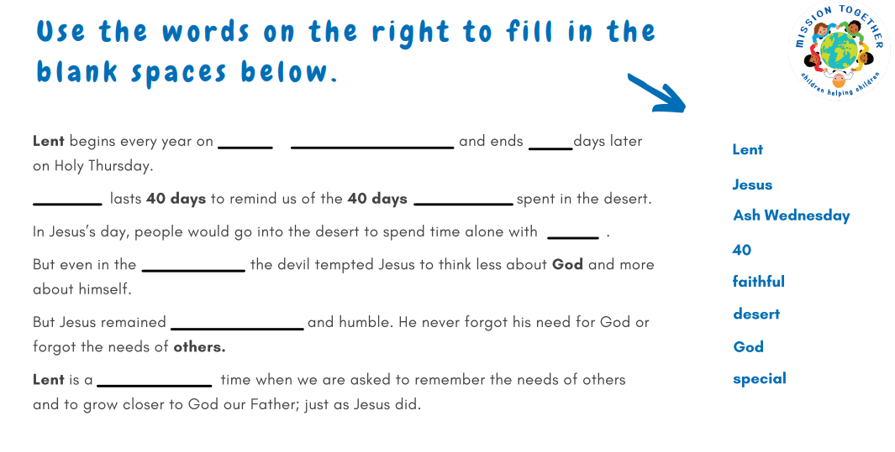

RE Lesson

Tuesday 23rd February