Monday 22nd February 2021
Can I predict what will happen in the story?
Can I use drama to portray how a character is feeling?
Starter
Try to find an old box of used crayons or look at the picture below – some broken, some stubby, some whole, and some with the wrappers taken off. Talk to someone in your house. Why do the crayons look like this?
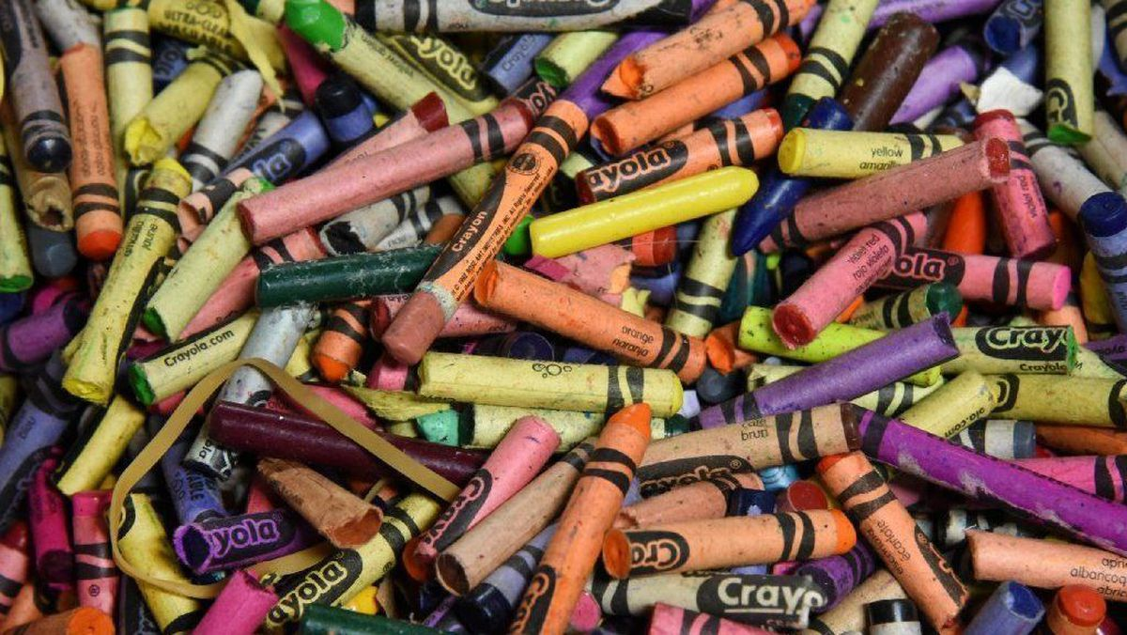
What has happened to the crayons to make them this way?
Why are some crayons much shorter than others?
Which crayons do the children think are the most popular?
Are there any crayons that seem never to have been used? Why might this be?

Take a look at the front cover of our new book…
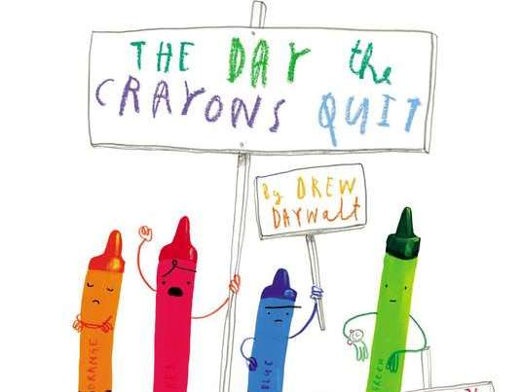

What do you think the story might be about?
How can you tell from the pictures?
What information does the title of the story give you?
What are the crayons doing? Why are they holding signs?
Main Task
Write six questions you would like answered about the book. You could try and answer them when you have finished reading the story.
Try to use each of the following question words:
Read the beginning of the story, up to the grey crayon.
Why are the crayons upset?
Are they all angry for the same reasons?
What do you think green crayon would have written? What about black?
What other colours could have written letters?
Now we are going to take on the role of the crayons and think about how they are feeling. Look at the illustrations of each crayon in the book – what is it about the face and the body of each crayon that puts across the emotion? Talk about how the drawings are quite simple, and yet we can still tell how each crayon is feeling (beige crayon is bent over, with its arms drooped downwards and a frown on its face). What emotion does this body position and facial expression convey?
Make a list of all the different emotions in your home learning journal.
Can you devise a freeze frame to sum up the emotion that their crayon is feeling?
• How would their faces look if they felt like this?
• How would their bodies appear if they were feeling this way?
• What images might they include in their freeze frames?
Send your freeze frames to us on Seesaw.
Success criteria
- Write 6 questions using capital letters and question marks
- Produce beautiful handwriting with lead-ins to every letter
- Use evidence from the text to help you
- Use clues from the illustrations in the story

