Preparing the Special Meal for the Parish Family

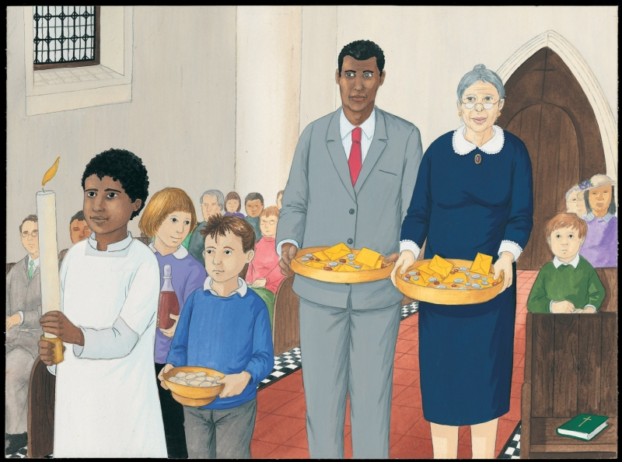
Last Sunday, when I went to church with Dad and Grandma, Mr Sheridan asked my friend Clare and me if we would take up the gifts of bread and wine to the altar in the procession of gifts. I had never done it before and I felt quite excited. When the time came, I held the dish with the altar breads, which are called hosts, and carried it very carefully. Clare carried the wine and Mr Sheridan and Grandma took up the collection. Father James smiled at me. “Thank you, Clare and Tom,” he said. When I returned to my seat, I watched Father James offer the gifts and listened as he asked God our Father to bless the bread and wine that would become Jesus for us. We all replied, “Blessed be God forever.”
- What is the food and drink for the special meal?
- What did Father James do with the gifts of bread and wine?
- What did the people reply?

