In addition to your main plan, make notes below to help you with your explanation. Answer some of these questions:
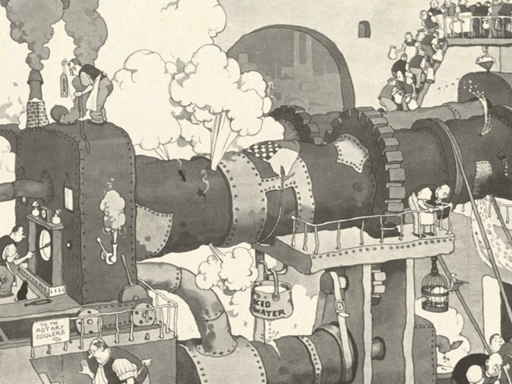
Machine’s name & purpose (and other key facts) | Technical Terms for different parts & actions
How it works

