Crazy Inventions Registered with US Patent Office (1)

The Squabble Shield
The Squabble Shield

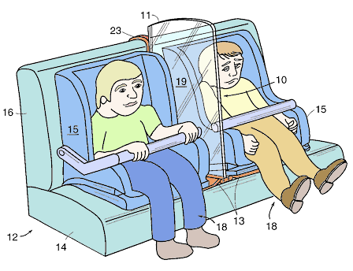
Crazy Inventions Registered with US Patent Office (2)
Doggie Umbrella

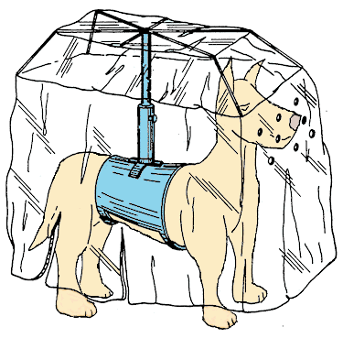

Crazy Inventions Registered with US Patent Office (3)
Flying Bike

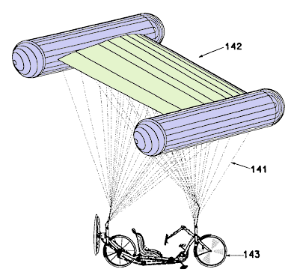

Crazy Inventions Registered with US Patent Office (4)
Tricycle Lawnmower

