Transport of the Future!

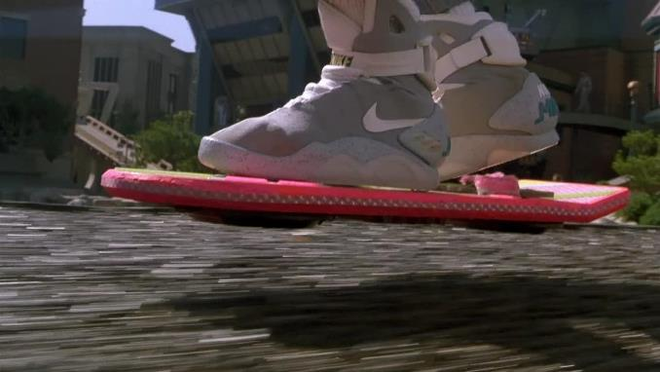
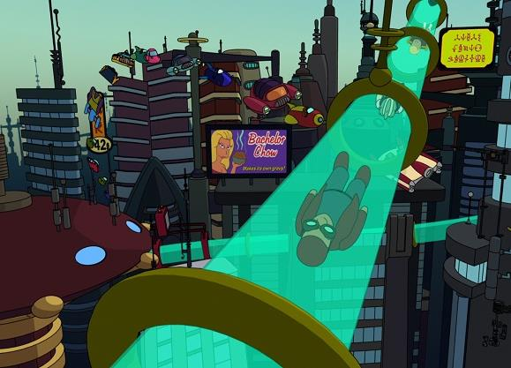
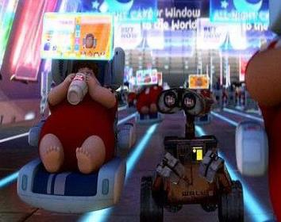
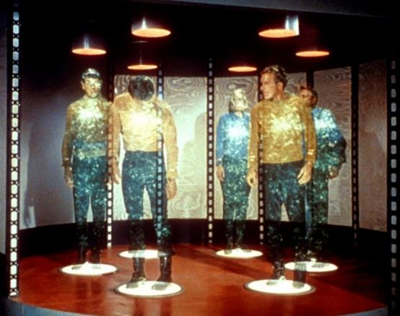
Ideas:
Rocket boots
Electric Skates
Teleportation watch
Back Pack Helicopter
Anti-Gravity Shoes
Glider sleeves
Hover Bed
Underground water chute
Worm Hole Creator
Bouncy Shoes
Robotic Trousers
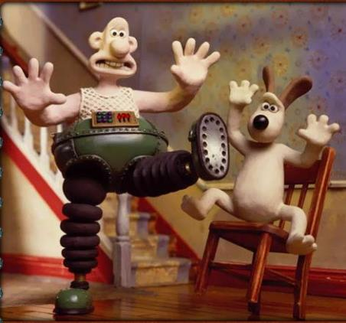
Giant Paper Aeroplane

