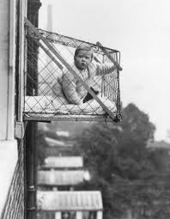
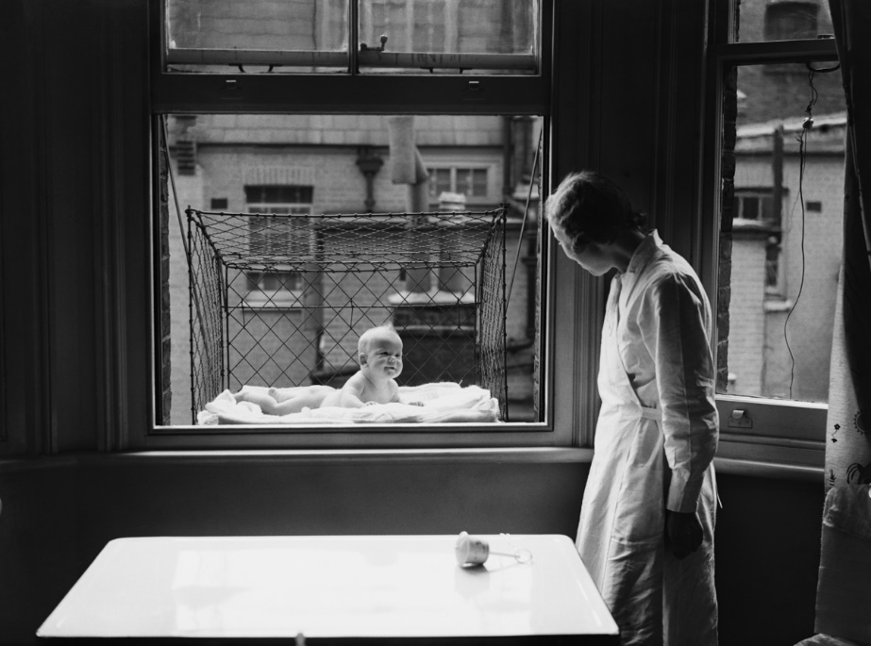
The Baby Cage (London 1930s)

These incredible pictures taken in the 1930s show babies suspended high up in flats from their parents' window.

Incredibly, the then East Poplar borough council in London proposed to fix the cages to the outside of some of their buildings so that babies could benefit from fresh air and sunshine.

The idea behind the cages was patented in America in 1922 (by Emma Read, from Washington) as a to help parents living in cities who didn't have much space. The benefits were said to be fresh air for the child, room to play with toys and another place for children to sleep.

The cages in the patent were also designed with a slanted, overlapping roof which was said to protect babies from snow or rain.

