Dragon Bones Mystery Cracked
Read the information about the discovery and purpose of oracle bones and answer the questions in as much detail as you can.
Dragon Bones in Medicine
In the 19th century, traditional Chinese medicine used ‘dragon bones’ which were ground up and put into tonics and creams to treat illnesses and heal wounds. These ‘dragon bones’ had been dug up and re-buried by Chinese farmers for thousands of years before they were used in medicines.
Dragons have had a special significance in Chinese culture for a very long time and they are seen as a symbol of power and good fortune. It was once believed that dragons could control nature – for example, the rain – and so dragons were worshipped in order to encourage them to be kind to the people.
Wang Yirong’s Discovery
In 1889, Wang Yirong, who lived in Beijing and was an expert on ancient Chinese bronzes, bought a number of ‘dragon bones. Wang and his friend Liu E studied some of the dragon bones and saw that the bones had writing on them like the writing on Wang’s bronzes. They worked out that the bones were not dragon bones after all but oracle bones.
After Wang’s death in 1900, his son sold the bones to Liu E who took rubbings of the writing on them. In 1903, Liu E wrote a book about oracle bones and included pictures of the rubbings. The book became very popular: people wanted to find out more about the interesting oracle bones.
In 1928, official archaeological digs began in Anyang. Around 20,000 fragments of oracle bone were dug up and ancient tombs were revealed. This was the first official proof that the ancient Shang dynasty had actually existed.
The Oracle Bones
The oracle bones were found to be the shoulder bones of oxen and other animals or the belly-shells of turtles. These bones were used because they are large and flat and they were easy to write on.
In the earlier Shang time, priests would write the king’s questions onto the bones; later, the king himself took over the role and would write his own questions. The questions were asked of the royal ancestors whom the Shang believed lived on as spirits in the afterlife and could help them make important decisions.
After the questions were written, a heated metal rod was pushed into the bone which caused it to crack. The king would then ‘read’ the cracks as the answer to his question. This is called ‘pyromancy’ which means ‘telling the future with fire’.
The discovery of the oracle bones taught us a great deal about the ancient Shang civilisation. The writing on the bones also tells us about Shang life, politics and all the Shang kings that ruled. It is a good thing that Wang Yirong found out what the ‘dragon bones’ really were before they were all made into medicine.

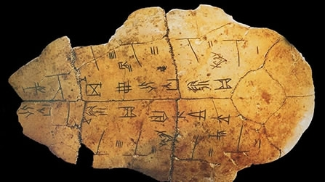

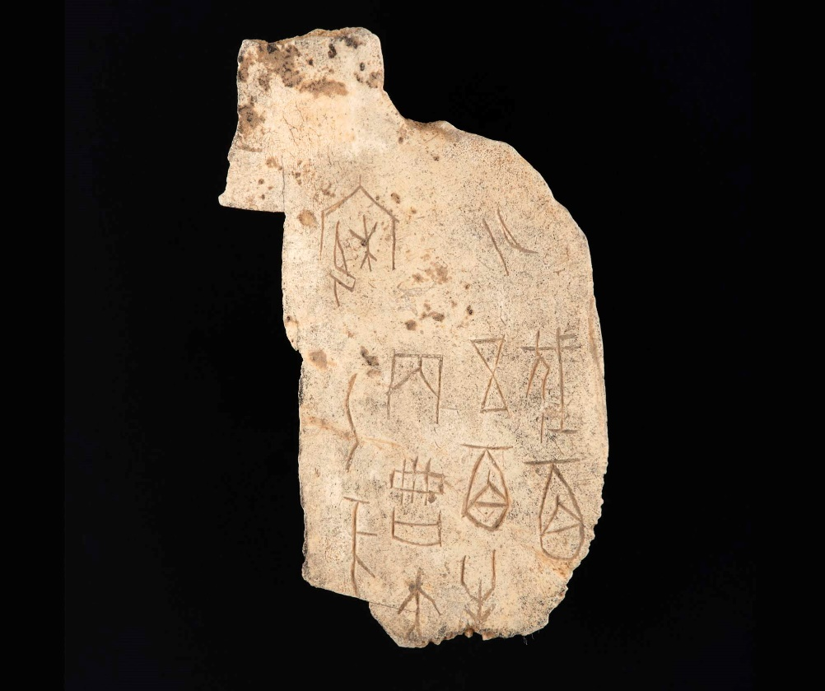

Dragon Bones Mystery Cracked
Questions
Now answer the questions in as much detail as you can.
- What were 'dragon bone' medicines used for in traditional Chinese medicine? __________________________________________________________________________________________________________________ __________________________________________________________________________________________________________________
- What do dragons symbolise in Chinese culture? __________________________________________________________________________________________________________________ __________________________________________________________________________________________________________________
- What did Wang Yirong find on the 'dragon bones'? __________________________________________________________________________________________________________________ __________________________________________________________________________________________________________________
- What happened to Wang's dragon bones when he died? __________________________________________________________________________________________________________________ __________________________________________________________________________________________________________________
- Why do you think Lui E's book was so popular? __________________________________________________________________________________________________________________ __________________________________________________________________________________________________________________
- When did the first archaeological dig begin in Anyang? __________________________________________________________________________________________________________________
- Why were the shoulder bones of oxen and the belly shells of turtles used as oracle bones? __________________________________________________________________________________________________________________ __________________________________________________________________________________________________________________
- Who wrote questions on the oracle bones? __________________________________________________________________________________________________________________
- Who did the king believe answered his questions? __________________________________________________________________________________________________________________ __________________________________________________________________________________________________________________
- What else was discovered about the Shang dynasty from the oracle bones? __________________________________________________________________________________________________________________ __________________________________________________________________________________________________________________

