**REVEAL –** The Eucharist keeps the memory of Jesus’ sacrifice alive and present in a special way.

**The Story of the Passover:**

Passover is a celebration of the story of Exodus. During Passover, Jews remember how their ancestors left slavery behind them when they were led out of Egypt by Moses. Passover is celebrated with a series of rituals. Each ritual symbolises a different part of the story.

Watch the story together:

<https://www.bbc.co.uk/bitesize/topics/znwhfg8/articles/zn22382>

<https://www.bbc.co.uk/bitesize/clips/zx7tfg8>

The Israelites had been enslaved in Egypt for many years their treatment at the hands of slave drivers got worse and worse, their boy babies were killed by Pharaoh and they were beaten. God saw their plight and had pity on them. He called Moses to be their leader and told him to ask Pharaoh to let the Israelites go. Pharaoh refused for a long time, then God sent some plagues on the Egyptians, the final one was the death of first-born children. God told the Israelites to smear the blood of a lamb they had sacrificed on the door posts of their houses. That way death would ‘pass over’ them. Finally, Pharaoh let the people go.

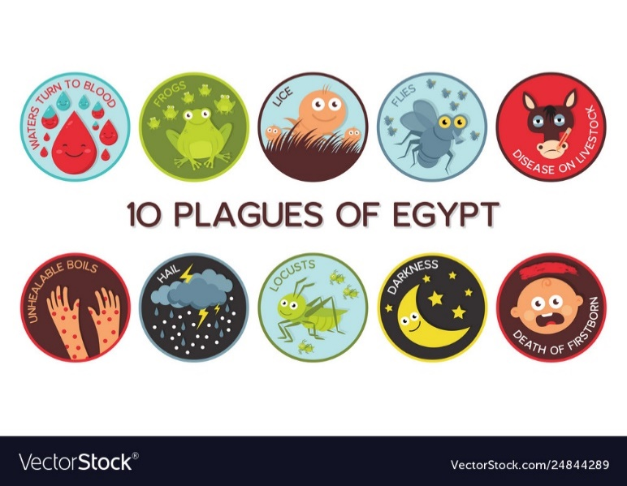

Ever since that time Jewish people have remembered the Passover when God saved them and lead them to freedom. In the Book of Exodus this is what Moses said to the people,

*“Remember this day – the day on which you left Egypt, the place where you were slaves. This is the day the Lord brought you out by his great power. No leavened bread is to be eaten.”*

Exodus 13: 3

For the Jewish people, remembering the events at Passover every year is very important. It makes those events present to them. In a certain way they become real to them and have the effect of changing their lives. (You might have studied this already in your work on Judaism.)

Here are some questions to think about:

**Q** Why did the Israelites want to leave Egypt?

**Q** What do you think is meant by ‘the sacrifice of the lamb’?

**Q** Why is the Jewish celebration of this event called Passover?

**Q** What is special about the way Jewish people remember Passover?

**Q** How do you think the events at Passover affects their lives?

**Activity:**

Make links to and give reasons for some of the symbols used at the Passover meal e.g. salt water, lamb, bitter herbs, charoset, unleavened bread and what happened to Moses and the Israelites at the Exodus.

To help you with this I have included a worksheet (documents below – The Passover Seder Plate).

Watch this clip about the symbols of the Seder Plate. Then, draw/colour a picture of each food on the plate and write what it symbolises. Don’t forget to draw Matzah in the middle of the plate!

<https://www.myjewishlearning.com/article/the-seder-plate/>

