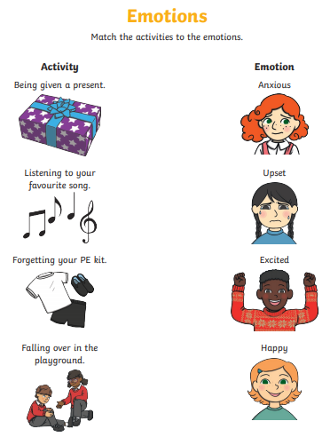

Can I List a range of feelings and emotions?
- ________________________________
- ________________________________
- ________________________________
- ________________________________
- ________________________________
- ________________________________
- ________________________________
- ________________________________

Being happy makes me feel _______________________________
______________________________________________________
______________________________________________________

Being anxious makes me feel ______________________________
______________________________________________________
_______________________________________________________

