Which birds lay the biggest and smallest eggs?
Biggest
Ostriches lay the biggest eggs in the world.
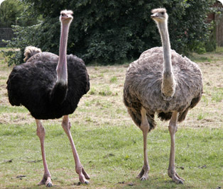This is how big an ostrich egg is compared with a hen’s egg.
Smallest
Hummingbirds lay the smallest eggs in the world, because they are the smallest birds!
