How Escalators Work
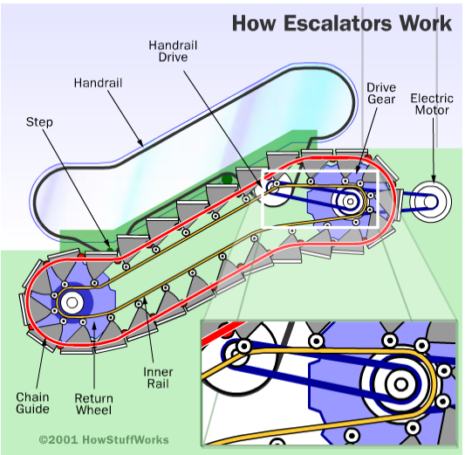
Escalators are easy to use. However, their design is far from simple. This article will explain how an escalator works and how they are more complex than a simple conveyer belt.

Escalators do not move a flat surface, as in a conveyer belt. Instead, the chain loops move a series of steps. Therefore, as the chains move, the steps always stay level. At the top and bottom of the escalator, the steps collapse on each other, creating a flat platform. Consequently, this makes it easier to get on and off the escalator. In the diagram, the internal workings of an escalator can be seen.

Each step in the escalator has two sets of wheels, which roll along two separate tracks. The upper set (the wheels near the top of the step) are connected to the rotating chains. As a result, they are pulled by the drive gear at the top of the escalator. Meanwhile, the other set of wheels simply glide along its track, following behind the first set.

CLICK for animated version of the diagram.

