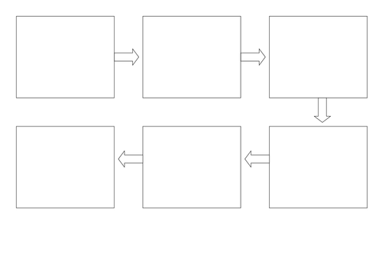

Can I use my own ideas? Can I talk about the beginning, middle and end of my story?

My Little Red Riding Hood Story Map by ______________ Wednesday 10th February 2021