Wednesday 10th February 2021
Can I plan a description of a setting?
The extract you have been asked to read or listen to gives a description of a fierce storm which breaks over the island.
Today, you are going to use your senses to write your own description of a storm – the storm doesn’t have to be on an island or in a forest or a jungle. You could be in the storm anywhere! You will need to describe the approach / start of the storm, the main part of the storm and the storm dying away to nothing. You will need to use your senses (what you can see, hear, touch, taste and smell) to help with your description.
- First of all – look through the extract on pages 89 to 90. Are there any words you can use in your own writing? Jot these down in your Home Learning book.
- Next listen to 1 to 2 minutes of extract 1. It is the sound of a thunderstorm in a jungle.
- Then listen to 1 to 2 minutes of extract 2. It is the roaring sound of thunder in a rainforest.
- Now listen to the extracts again, but as you do so, jot down words that describe what you can hear. What do you think you could see, taste, smell and touch? You can use the planning sheet on page 2, or you could make your own.
Make sure you think about:
- The sound of the rain
- The amount of rain
- The sound / appearance / smell of thunder and lightning
- Waves (if you are on an island)
- The sounds / appearance of any animals
- Items that may be moved or destroyed because of the storm

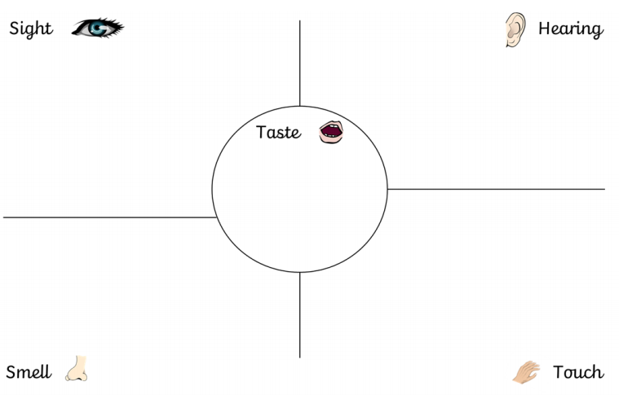

Can I use my senses and ambitious vocabulary to describe a setting?
Now you have collected some words to describe the storm and thought about your senses, you should be ready to write your setting description. It does not have to be really long. A couple of really descriptive paragraphs where every word used is thought about carefully is far more powerful. When I read your descriptions, I should be able to imagine I am in the storm.
Try and build the description using all the different senses.
In your writing today, please focus on:
- Capital letters and punctuation
- Perfect spelling and beautiful handwriting
- Using the first person (YOU are in the storm)
- Including your senses to help with description
- Using ambitious vocabulary
- Using a variety of sentence openers (ISPACE – see page 4)
- Writing at least 3 sentences starting with a ‘subordinating conjunction’.
For example choose 3 of the following as sentence openers:
because, after, while, when, although, before, as, if, even though, despite, since

I have included a short example below.
That evening, I saw the bright flash of lightning before I heard the muffled crack of thunder. My nostrils picked up the scent of ozone in the air. Before I knew it, a formidable storm broke over the island. The fierce winds made the trees thrash in the air, as the sand whipped aggressively at the rocks, along the shore and in my face. All around me I heard the deafening clap of thunder intermittent with rain lashing down like a waterfall. Across the sky, lightening forked, illuminating the vast, roaring waves, which curled and lashed in the sea. Despite taking shelter in my cave, the taste of salt was on my lips. The storm started to weaken and eventually the crashing waves became tranquil ripples. Because of its ferocity, I was eager to see the damage to my surroundings. Leaves and branches were littered everywhere and the forest symphony started up where it had left off. Calm had been restored. My paradise was tranquil. I had survived the storm!

