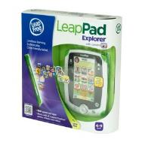
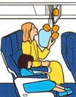
Thinking about Instruction Texts

- Read both texts carefully before answering the questions
- Write answers in your exercise book.

LeapPad Instructions

1. How many player names can be stored at one time on the LeapPad?
2. Name 3 items you can buy at the LeapFrog App Centre.
3. What imperative (bossy) verbs can you find?
4. What sort of information is put in brackets?
5. These instructions are for a child's toy. Are they written for children? How can you tell?
6. What tricks (devices) has the writer used to organise these instructions? How do they help?

Aeroplane Instructions

7. Where can you find a life jacket?
8. Where should luggage be kept when the plane is landing and taking off?
9. Who do you think is the intended audience of these instructions? How has the writer tried to make the text suitable for the needs of this audience?
10. Write an instruction sentence to go with the last box (remember the imperative verb).

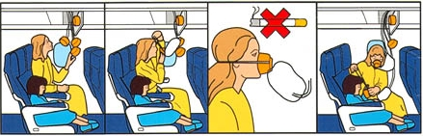
Key Vocab
oxygen mask
overhead compartment

Both Instructions

11. Which text do you think gives instructions most clearly? Explain why.
12. Which text would you improve and how?

