Public Information Poster 1916
How to Board a Bus Safely

For your safety, it is very important that you follow these simple instructions when boarding one of our motorised buses:
- First, always face slightly towards the front of the bus.
- Next, take hold of the hand rail on the door side with your left hand.
- Finally, step onto the bus with you left foot first.

SAFETY FIRST!
WAIT UNITL THE BUS STOPS!

- Don’t take hold of the staircase, only use the railing.
- Don’t try to board with hands full of parcels.
- Don’t face in the opposite direction to that in which the bus is proceeding.

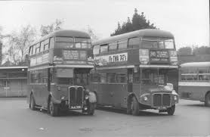

Enjoy your trip and please come aboard again!

