Tuesday 9th February

Please read the text (attached in uploads) for today’s lesson. If you have the book it is Chapter 10. Read from page 134 to the end of the chapter.
Here is the link to watch it on YouTube: listen from 17.53 to the end.
https://www.youtube.com/watch?v=Re_mzpr7xcg&safe=active

Main Lesson
Today we are going to look at key features in a newspaper report. This week we are going to write different parts of the newspaper report all about Initiation Thors’day Thursday.
Let’s have a look at some features of a newspaper report today.

Task
Here are some example newspaper reports. There are 3 in total.
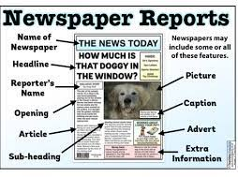
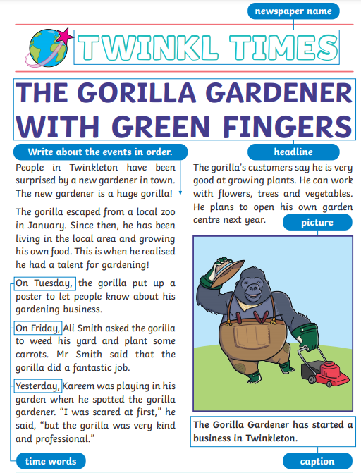
- Can you list the features that you see in each one?
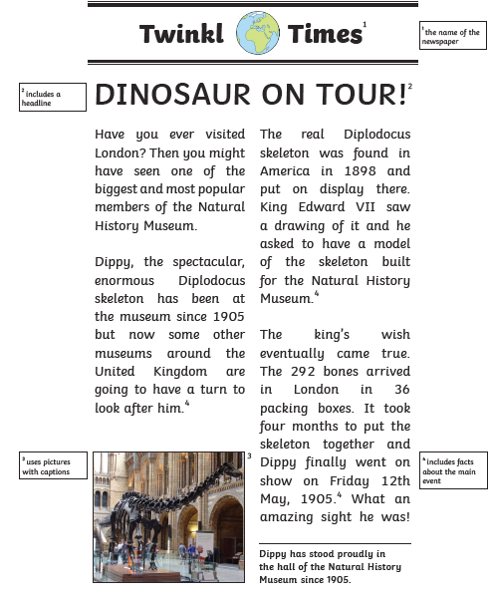
1
2

3

- Can you think of a Name for your Newspaper?
Try and think about the story, where they live, what the tribes are called, what the Islands are called.
Thinking about the details from the story about what we have already read will help you come up with some good ideas you could use for what your Newspaper is called.

- Can you think of a Title/Headline for your News Report?
Remember the report is all about Thors’day Thursday so you might want to include these words in your title.

Success Criteria
- Make 3 lists for the features of a Newspaper report.
- Use Capital Letters for your Newspaper name and title.
- Send a picture of your predictions to SeeSaw.

