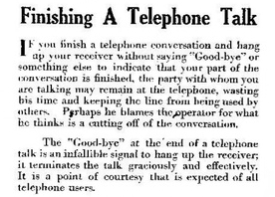
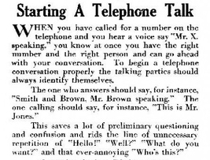
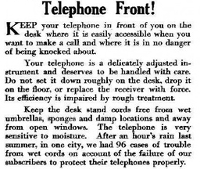
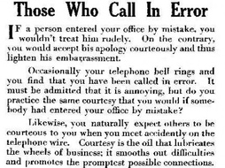
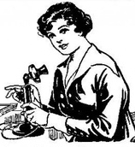
How to Use the Telephone, 1917
These are pages from an instruction book for users of a new technology: the telephone. Telephones were only used by a lucky few at this time, so that simple conventions (such as saying 'hello') had to be explained.

Your task

- Read these instructions carefully, highlighting the key rules.
- Create a clear and cohesive list of instructions for 1910s telephone use, based on this text.
- Use adverbs to link the ideas.

