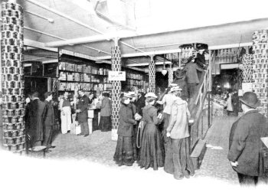
How to use an Escalator

Britain's first moving staircase was installed in Harrods in November 1898. Shoppers flocked to the store and Cognac and smelling salts were available for the faint-hearted.

Imagine you had never used an escalator before. What would you need to do to keep safe?
What actions might end in an accident?

Your task
- Write a list of instructions for safe escalator use, with ideas linked by adverbs.

Collect ideas

- Talk about your ideas with a partner; you might wish to act out each step to help you think of ideas for safe use.
- Make a note of each step.

Write a list of instructions

- First, write an introductory sentence, explaining what the instructions are for.
- Next, write each step linked by adverbs.
(You might use adverbs for time order or to introduce a cause, a contrast or modify an imperative verb.)
- Lastly, consider including a labelled diagram or two.

Check
- Reread, checking for sense and punctuation.

