Instructions for Boarding a Bus

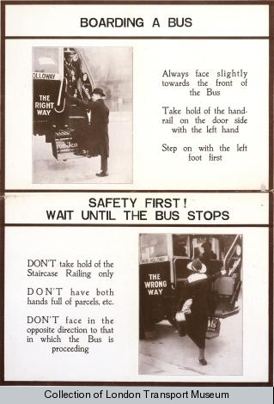
Motorised buses replaced horse-drawn buses by 1914 in London.
Public information Poster, 1916

