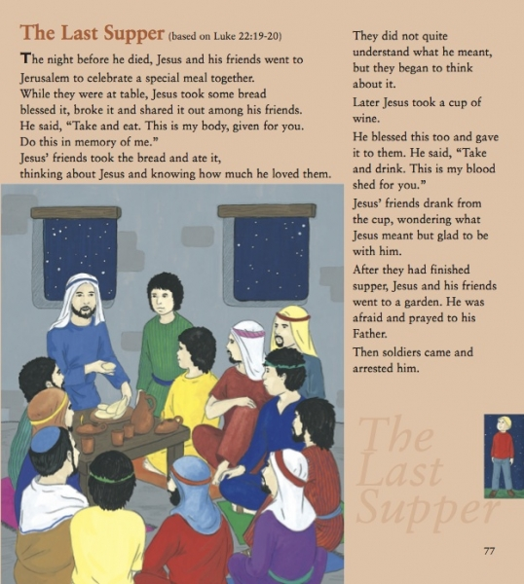
- Why was this called the Last Supper?
- What did Jesus do and say?
- What food and drink did Jesus and his friends share?
- What did Jesus ask people to do?
- During Mass who does what Jesus did at the Last Supper?

