**Card Games 1**

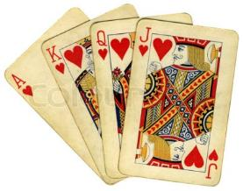

**Royal Cards**

These are King, Queen, Jack or Ace in each suit.

**How to Play Slap Jack**

*You need 2 – 4 players and a pack of playing cards.*

* First, shuffle and deal out all the cards in a pack between the players, face down.
* Then, keep cards face down in front on the table.
* Next, take it in turns to turn over your top card and then place it in the middle on to a discard pile.
* Whenever a Jack is turned up the first player to slap it wins.

**Extra Information**

It may be fairer if players slap the discard pile on seeing the Jack, otherwise the player holding it may have the advantage.

* You can play this to include all royal cards.
* The winner of the jack can either get points or win the cards underneath.