**How to Play Sevens**

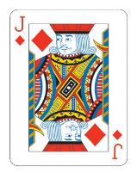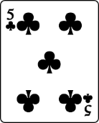

A **Jack** (or knave) can be recognised by a J on the corners and means the next player misses a turn.

A **suit** means one of the 4 groups of cards:

**Hearts**, **Diamonds**, **Clubs** or **Spades.**

This card is a **club**

*You need 2 – 6 players and a pack of playing cards*

* Firstly, deal seven cards to each player.
* Then, turn one of the remaining cards face up, and place the rest in a pile face down.
* Now, players take it in turns to play.
* Each player places a card face-up on top of the card which is already face-up in the middle, creating a pile of cards which are face-up.
* BUT a player may only place one of their cards on this pile if the card they are placing is the same suit or the same number as the card which is on top of the pile.
* If a player cannot play when it comes to their turn, they must take a card from the face-down pile of cards.
* A ‘7’ is a ‘wild card’ and may be played at any time, on any number or suit.
* Playing a ‘Jack’ means that the player following you must miss a turn.
* **Finally, the player to get rid of all their cards first is the winner!**

**Extra Information**