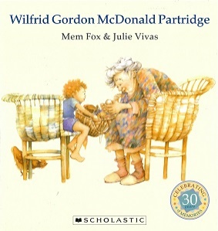

MEMORIAL SACRIFICE - SACRAMENT – EUCHARIST
Lesson 1: Explore – How memories are kept alive.

Ask the question: What is a memory? and talk about the responses. Share some of your special memories and what things brings them to mind - it might be an object, a sound, a song, a smell, a photo etc. Discuss why these things trigger memories and how important they are.

Share some photos of events that have happened in the life of your child. What are their memories of these times and how do you all keep those memories alive?

To look at how we can keep memories alive, you might like to read the book, ‘William Gordon McDonald Partridge’ or watch a clip of it on:
https://www.youtube.com/watch?v=usnOEnTXabw

Think about these questions:

Q Why was Miss Nancy, Wilfred Gordon McDonald Partridge’s favourite person?
Q What kind of memories did the people in the home have?
Q What helped them to remember?
Q What did the memory basket do for Miss Nancy?
Q Why do you think it was important?

Activity:

At the moment, we are living with the effects of the COVID19 pandemic and we have been doing things a bit differently from our normal way! How will you remember these times? Make a list of good things and bad things to remember in the future. You could make a ‘time capsule’, a collage or a video about COVID days to help you to remember what you did and how you felt at this time.

I have made a worksheet, COVID-19 Pandemic - Good and Bad Times, to help you with your work (documents below).

