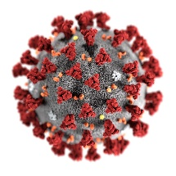
COVID-19 Pandemic - Good and Bad Times
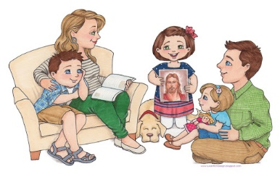
Good Times Bad Times

________________________________________________________________________________________________________________________________________________________________________________________________________________________________________________________________________________________________________________________________________________________________________________________________________________________________________________________________________________________________________________________________________________________________________________________________________________________________________________________________________________________________________________________________________________________________________________________________________________________________________________________________________________________________________________________________________________________________________________________________________________________________________________________________________________________________________________________________________________________________________________________________________________________________________________________________________

