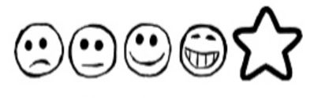
Monday 8st February 2021 Mass on Sunday

Can I talk about what happens during Mass?
Draw your pictures in the boxes.

