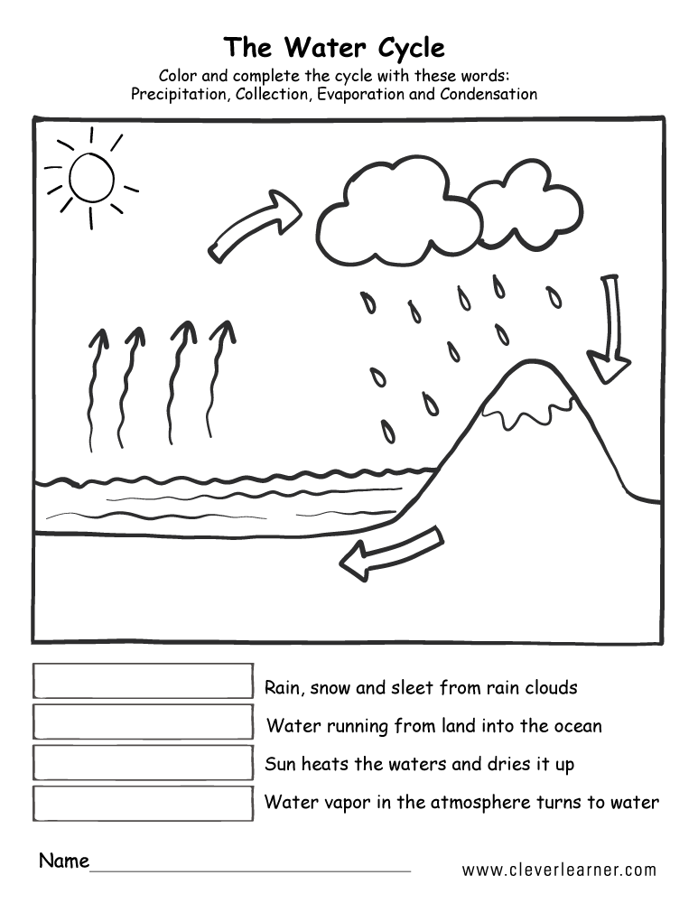

**The Water Cycle**

Colour and complete the cycle with these words:

Precipitation Collection Evaporation Condensation