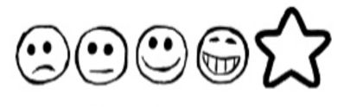
Thursday 4th February 2021 Speech Bubbles

Can I write what the characters say?
Can I use my sounds to spell my words?

