ST OSWALD’S CATHOLIC PRIMARY SCHOOL
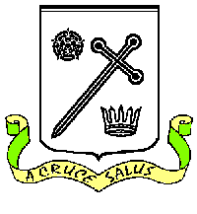
HOLIDAY LIST 2023-2024

Autumn Term 2023

INSET day Friday 1 September 2023
INSET day Monday 4 September 2023

School opens Tuesday 5 September 2023
Half-term:
Close Thursday 19 October 2023, 3.15 pm
INSET day Friday 20 October 2023
Re-open Monday 30 October 2023
School closes for Christmas Thursday 21 December 2023, 1.30 pm
INSET day Friday 22 December 2023

Spring Term 2024

School opens Monday 8 January 2024
Half-term:
Close Thursday 8 February 2024
INSET day Friday 9 February 2024, 3.15 pm
Re-open Monday 19 February 2024
School closes for Easter Thursday 28 March 2024 3.15 pm

Summer Term 2023

School opens Monday 15 April 2024
School closed for Bank Holiday Monday 6 May 2024
Half-term:
Close Friday 24 May 2024, 3.15 pm
Re-open Monday 3 June 2024
School closes for Summer Friday 19 July 2024, 1.30 pm

HOLIDAYS/ABSENCES DURING TERM TIME ARE NOT PERMITTED EXCEPT IN “EXCEPTIONAL CIRCUMSTANCES” AT THE DISCRETION OF THE HEADTEACHER

INSET days:
Friday 1 September 2023
Monday 4 September 2023
Friday 20 October 2023
Friday 22 December 2023
Friday 9 February 2024

