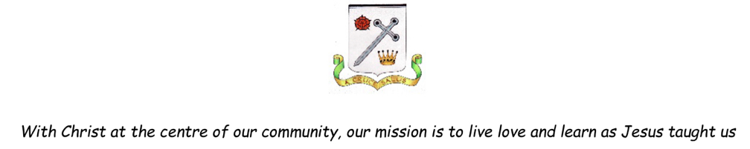

Music Progression in Key Skills

Year Group | Key Skills
Year 1 | Experiment with creating and copying musical patterns.  Begin to explore the sounds of their voices and various musical instruments, recognising the differences between singing and speaking and wood, metal, skin (drum) and 'shaker' sounds.  Identify high and low pitches, sounds of long and short duration and recognise the difference between long and short sounds.  Identify silence and sounds that are loud and quiet and the differences between fast and slow speeds.  Understand how sounds can be made in different ways and described using given and invented signs and symbols.  Listen to contrasting songs (such as lullabies and dance / up-tempo) with concentration, remembering specific instrumental names and sounds.  Rehearse and perform with others, using untuned instruments and voices to sing songs, speak chants and rhymes  Perform with confidence cumulative songs (songs with a simple melody that changes each verse).  Begin to explore their feelings about music using movement, dance and expressive language.  Develop an understanding that music has been composed throughout history
Year 2 | Experiment with creating their own musical patterns and begin to identify one strand (section) of music or more.  Begin to improve their own and others' work.  Recognise the difference between a steady beat and no beat and identify sections within a piece of music which sound the same or different.  Understand that tempo means speed, and identify the tempo of music as fast, moderate, slow, getting faster or getting slower.  Listen with concentration to music of a longer duration and recognise simple structures (for example, a beginning, middle and end).  Understand that music can be used for particular purposes and occasions.  Play tuned and untuned instruments.  Use their voices expressively to rehearse and perform with others, recognising a song with an accompaniment (instrumental backing) and one without.  Can start and finish together and can keep to a steady pulse.  Recognise and match sounds with pictures of different instruments.  Explore a variety of vocal qualities through singing and speaking.  Begin to use onomatopoeia sound words to describe selected sounds and the ways in which they are produced.
Year 3 | Begin to improvise and develop rhythmic and melodic material when composing, improving their own and others' work in relation to its intended effect  Begin to create and combine a variety of the inter-related dimensions when composing (e.g. composing using both dynamics and tempo).  Understand that dynamics means volume and can recognise various different levels.  Understand that texture refers to the difference between thick (many sounds) and thin (few) layers of sounds.  Experience how music can be produced in different ways, including through ICT, and described through relevant established and invented notations.  Listen with extended concentration and begin to express their opinion on a range of live and recorded music.  Explain their ideas and feelings about music using movement, dance and expressive language  Begin to understand how music can be organised to communicate different moods and effects (e.g. listening to loud and fast music will create a different feeling to slow and quiet).  Determine upwards and downwards direction in pitch when listening and reviewing music.  Sing songs (also imitating melody patterns as an echo), speak chants and rhymes in unison, with clear diction, control of pitch and musical expression presenting performances with an awareness of the audience.  Play tuned and untuned instruments with increasing control and rhythmic accuracy, responding through gestures or movement to changes in the speed of the beat.  Sing solo songs demonstrating call and response form, speak chants and rhymes in unison with clear diction, control of pitch, a sense of phrase and musical expression.  Explore and compare sounds of groups of musical instruments, identifying the differences between them, e.g. strings, woodwind, orchestra, rock band etc.  Begin to explore the history of music, understanding that time and place can influence how and why music is created, performed and heard.  Explore music from a culture different to their own.
Year 4 | Improvise and develop rhythmic and melodic material when composing.  Experiment with gestures to show the overall contour of the pitch of a melody as it moves upwards, downwards or stays the same.  Combine a variety of musical elements when composing using staff and other musical notations.  Identify through gestures such as clapping or using percussion, the strong / first beat whilst singing.  Keep a steady beat and maintain rhythmic accuracy holding their own beat against another contrasting part.  Recognise pitch movement by step, leaps or as repeats.  Review their own ideas and feelings about music using art, movement, dance, expressive language and musical vocabulary.  Understand that time and place can influence how and why music is created, performed and heard. Listen to and review music from a culture different to their own.  Identify contrasting sections of a song, such as the verse and refrain (chorus).  Explore and compare sounds from the different instrumental families (percussion, woodwind, brass, string), name a variety of instruments  Hear in a piece of music, refer to and compare the different sounds instruments make as their tone colour such as brassy, wooden and metallic.  Sequence various famous composers on a timeline.
Year 5 | Improvise and develop a wider range of rhythmic and melodic material when composing.  Choose, combine and organise a variety of the inter-related dimension of musical elements when composing with staff and other musical notations, such as graphic scores and / or using ICT.  Recognise a musical phrase is like a musical sentence and can identify its duration as short or long.  Can identify a silence in a rhythmic pattern with a gesture such as raised hand.  Begin to use various Italian musical terms such as crescendo, diminuendo, forte and piano.  Begin to make suggestions of how the inter-related dimensions can be enhanced within musical structures to communicate different moods and effects (e.g. how can the tempo be changed to create excitement?)  Demonstrate a better understanding of the history of music. Begin to make appropriate suggestions of suitable pieces for music for various occasions.  Independently sing songs, speak chants and rhymes in unison and two parts, with increasing clear diction, control of  pitch, a sense of phrase and musical expression  Perform a variety of repeated rhythmic patterns (ostinato) on percussion instruments.  Begin to explore and compare a variety of contrasting sounds, recognising where the texture (thick (many sounds) and thin (few) layers of sound) varies in a song or piece of music.
Year 6 | Improvise with their voice or on a musical instrument both solo and ensemble to develop a wide range of rhythmic and melodic material when composing.  Can compose for different moods and use dynamic levels such as accents (sudden loud or sudden quiet notes).  Recognise a metre (the way in which beats are grouped) of three (such as in a Waltz) or four (most pop songs) and begin to recognise a change of metre within a piece.  Use Italian musical terms for gradually getting louder crescendo and gradually getting quieter diminuendo.  Know that time and place can influence the way music is created, performed and heard. Can make informed suggestions of suitable pieces of music for various occasions.  Develop a better understanding of the history of music. Begin to investigate the different eras of music.  Independently sing songs, speak chants and rhymes in unison and two parts, with confident clear diction, control of pitch, a sense of phrase and musical expression.  Practise, rehearse and present a variety of solo and ensemble performances with confidence and awareness of the audience.  Explore and compare a variety of sounds in a piece of music, identifying the prominent melodies.

