Storyboard Planning Template. Name of your story: ___Silas and the Mountain Adventure________
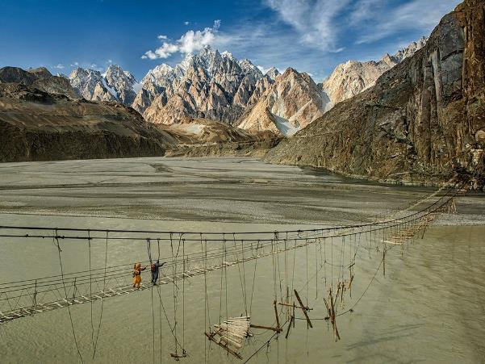 | 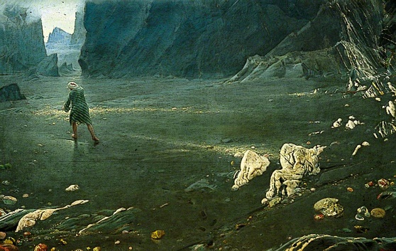
On one of his many voyages, Silas’ ship stopped at a beautiful but desolate, mountainous island, covered with rocks.  Describe the setting and Silas more.  He went ashore and decided to take a nap. | Waking, Silas discovered that the ship had set sail without him! He explored and discovered a white rock. A huge shadow fell over him, cast by a huge bird. The rock was actually the bird’s egg! Silas tied himself to the bird’s legs to escape the island, eventually landing in a valley full of diamonds, surrounded by steep mountains. | Pirates, who wanted the diamonds, threw huge stones down from the ridges. They had stolen Silas’ ship and taken the crew as prisoners. They wanted the diamonds for themselves.
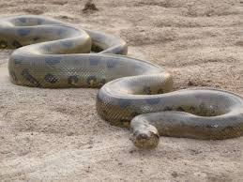 | 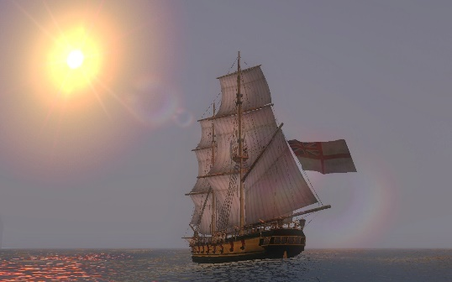 | 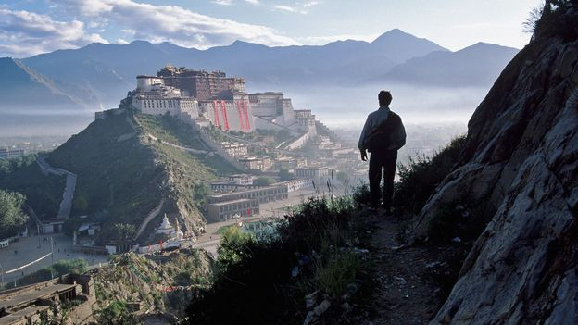
Silas filled his pockets with diamonds but huge snakes came out at night, which Silas escaped from by crossing the old rickety bridge. In the morning, he found his ship empty! | He went on board and found his crew tied up but the pirates were nowhere to be seen. They had been eaten by the huge snake. Silas freed his crew and they escaped from the Valley of Diamonds. | Many months later, Silas arrived home in Tibet, tired but very rich due to all the diamonds he discovered.

