2 times table bingo sheets
• Print off and cut along the bold lines so each sheet has 6 numbers on it.

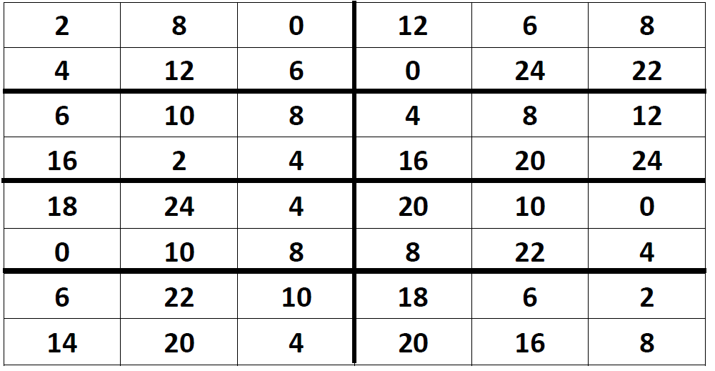
5 times table bingo sheets
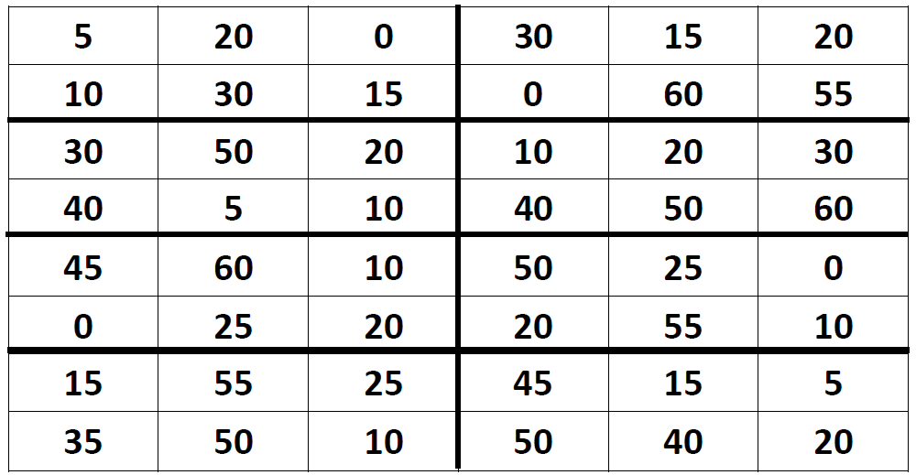

10 times table bingo sheets
