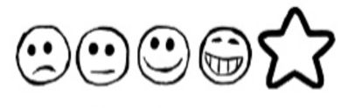
Monday 1st February 2021 Little Red Riding Hood

Can I think of words to describe a character from the story?
Can I use my sounds to spell my words?

The character from the story I have chosen is_____________________________________

