My Treasure Island by___________________________________ Thursday 28th January 2021
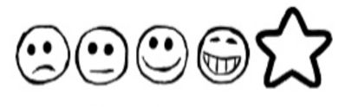
Can I use my own ideas to draw a treasure map?
Can I use the sounds I know to write words?

