Can I research the characteristics that make a plant adapted to its environment?
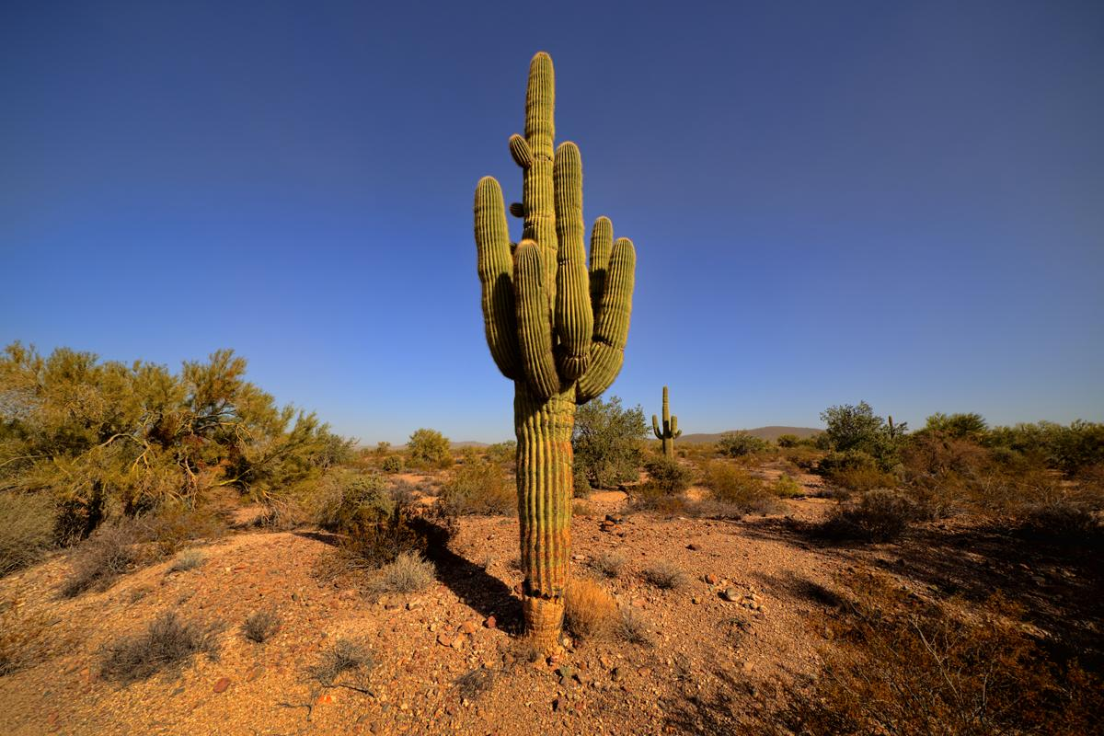
Thick waxy skin
Large, fleshy stem
Spikes
Shallow, widespread roots
Pleated skin

