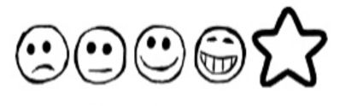
Wednesday January 27th 2021 My Message in a Bottle

Can I use my own ideas to write a message?
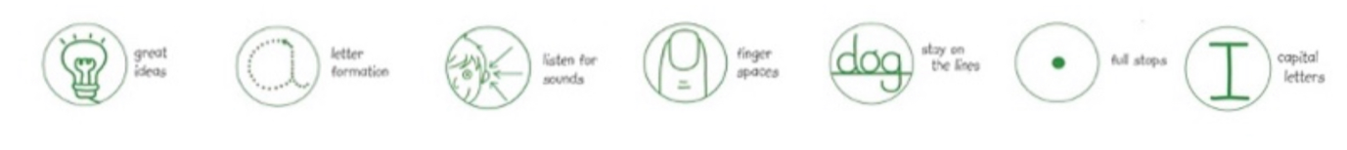
Can I use my sounds to spell my words?

This is a picture of where I am

_Dear________________________________________________________________________________________________________________________________________________________________________________________________________________________________________________________________________________________________From______________________

