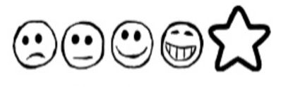
Tuesday 26th January 2021 My Pirate Story

Can I use my own ideas to write a story?
Can I use my sounds to spell my words?

________________________________________________________________________________________________________________________________________________________________________________________________________________________________________________________________________________________________________________________________________________________________________

________________________________________________________________________________________________________________________________________________________________________________________________________________________________________________________________________________________________________________________________________________________________________

