Monday 25th January
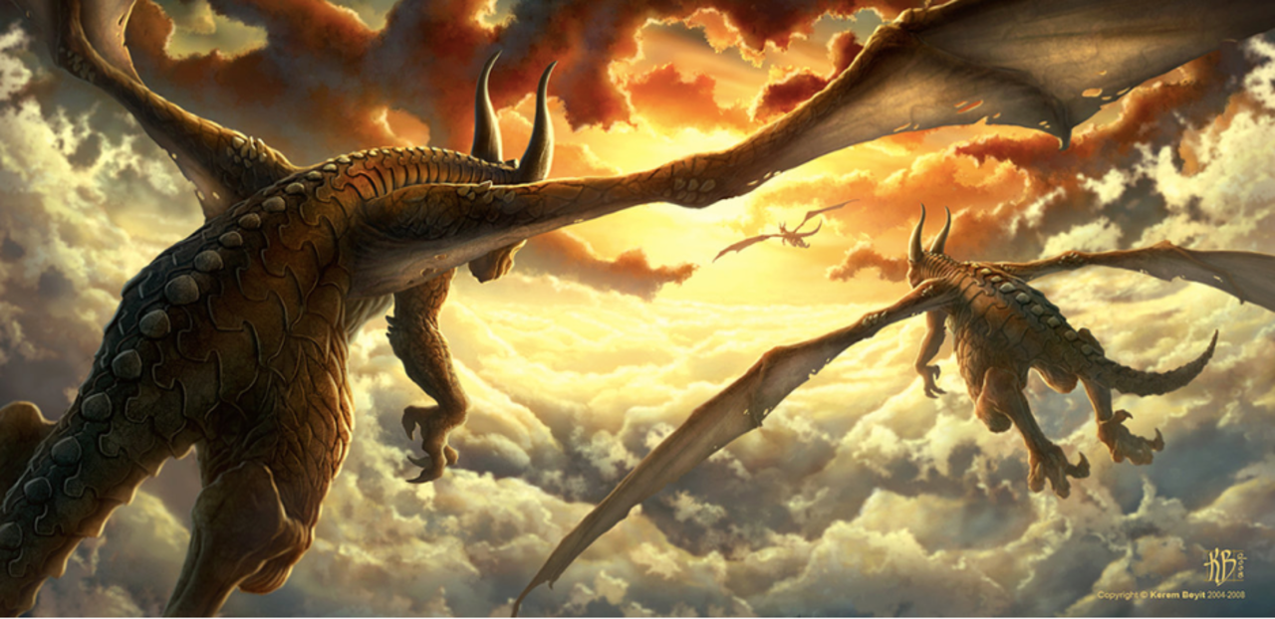

Starter:
Look at the picture and discuss what you can see with an adult. Have a go at these questions:
Where are the dragons heading?
What is ‘paradise’? Why are they looking forward to it so much?
Are these the only 3 dragons that exist, or are there more?
Where have the dragons come from? Where is their home?
If you had a pet baby dragon, how would you look after it?
Main Lesson:
Read the following text from the picture:
This was their favourite time of day to fly.
As the glowing, crimson sun dipped down below the vast horizon, retreating to allow night to take its place, the dragons took flight.
Can you carry on the description for the picture? Try and use some of the great vocabulary below to make your sentences interesting.
beautiful wisps of pillow-like clouds flexed their powerful wings
sun’s fire Thousands of tiny scales embracing
glistened like rubies dazzling light ocean blue soared

What I’m looking for in your work:
- Lead-ins on every letter.
- Finger spaces, capital letters and full stops.
- COUNT your words on your fingers before you write.
- To use an adjective in every sentence.
- To write half a page.

