Can i make supertato?

RESOURCES NEEDED TO MAKE SUPERTATO AND EVIL PEA:
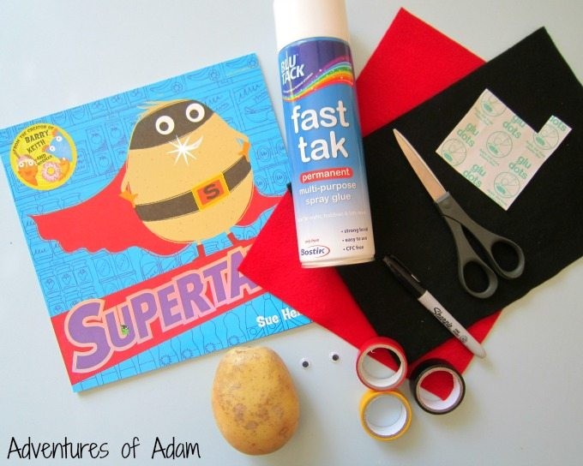

HOW TO MAKE SUPERTATO:
1. Place a strip of black electrical tape around the middle of the potato.
2. Add a rectangle of yellow electrical tape and then a small rectangle of red electrical tape to form a belt.
3. Use a black permanent marker pen to form the letter S inside the red square.
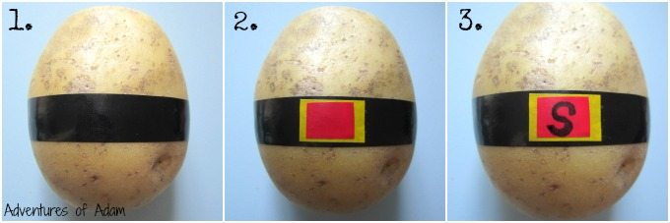
4. Place another strip of black electrical tape to the top of the potato and attach two googly eyes.
5. Using red felt cut out the shape of a cape. Attach cape to potato.
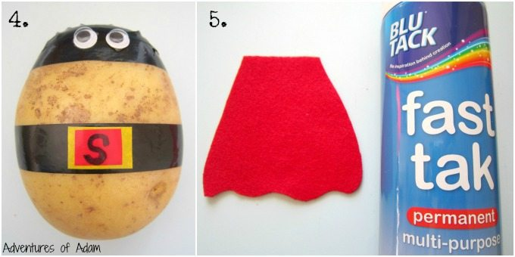
6. Use the black permanent marker pen to draw a smile onto Supertato.

