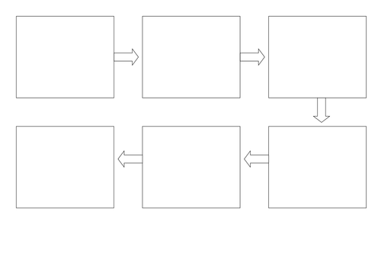

Can I use my own ideas? Can I talk about the beginning, middle and end of my story?

My Pirate Story Map by ______________ Monday 25th January 2021