Dragon Art activities for the week

We have come up with some Art activities for you to complete if you would like to. It would be nice to see what you create but please don’t feel like they are **all** compulsory.

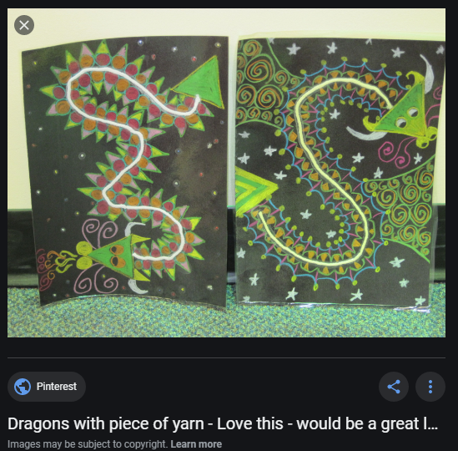

Chalk/crayon/felt pens ‘wool/yarn’ dragons.

Put your piece of wool/string/spare shoe lace onto your piece of paper.

Glue it where you think looks best.

This is the spine (middle) of your dragon picture.

Use the picture to create your own patterns for your dragon.

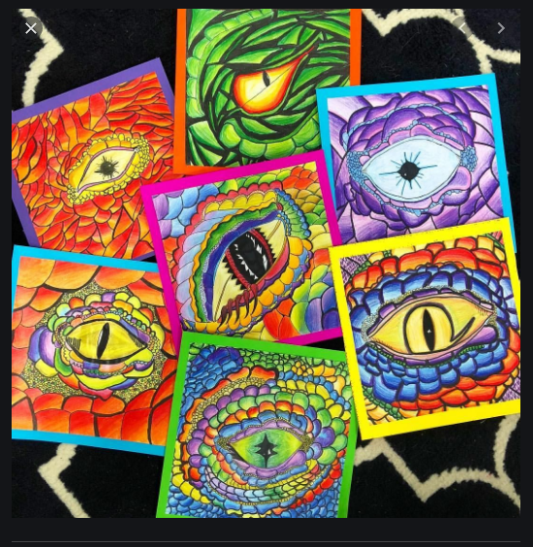

This is a great art activity which you can make much simpler.

Using lots of colours and curved lines to create the dragon’s eye effect.

Start with a basic eye shape then let the children be creative!

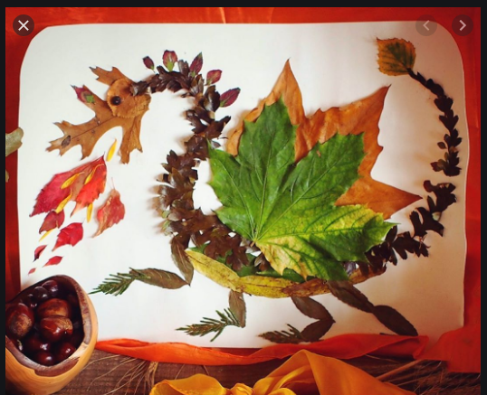

During a walk outside, collect some leaves, stones, sticks, acorns, grass.

Create a dragon using natural resources.

You could try to stick it to paper or make one outside and take a picture.

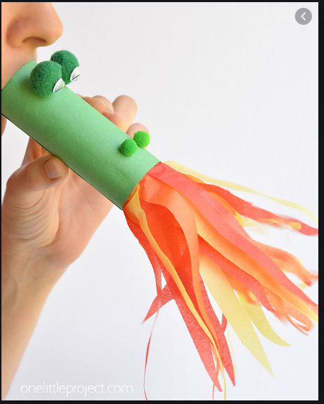

Any spare recycling would be great for this.

You could use a toilet roll holder/kitchen roll/tube.

Try and paint or colour in the tube for your dragon.

Attach coloured tissue paper for its fire.

If you don’t have pompoms or eyes you can draw these on too.

See if it works by blowing down the tube!

Materials

* aluminium foil
* air-dry clay/playdough
* liquid watercolours or food colouring
* acrylic beads, jewels and stones; seashells, beach glass and rocks; anything else that might embellish a dragon's egg

Instructions

1. (Optional) If you are using a coloured clay, skip to step 2. If you are using a white clay, you may want to stain it by mixing with liquid watercolours or food colouring.
2. Roll aluminum foil into a ball/egg.
3. Cover the aluminum ball with clay and sculpt it into an egg form.
4. Decorate with beads, jewels, and seashells by pushing them into clay.
5. Let the eggs dry for about 24 hours.
6. (Optional) At this point, you can paint them again.

