Pirate Ship Art
This lesson combines many techniques: drawing, cutting and shaping with paper, painting waves and composition.
Supplies:
- Brown, black, white and grey paper ( cut the white, black and grey paper in 4″ x 6″ pieces, the brown/black in long strips for masts and a larger brown for the hull)
- scissors and glue sticks
- oil pastels or crayons
- white paper
- paints in blue/green/purple/light blue and white and red/yellow
- paint brush
Step One: Creating the Ocean
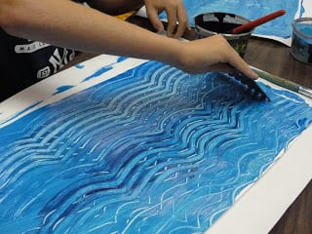
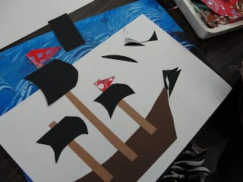
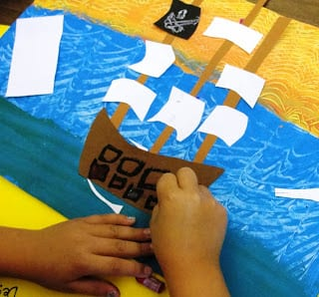
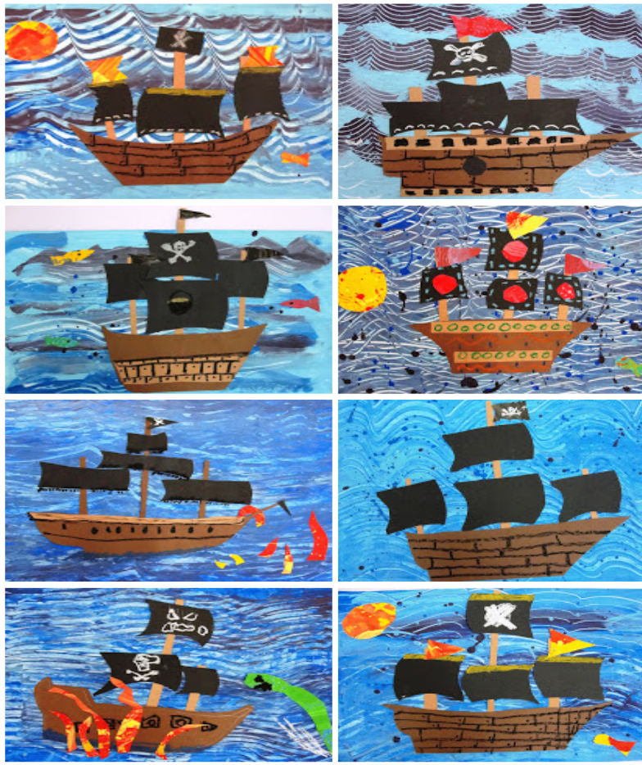
Paint the entire paper with one blue. If you want to have a sunset, add a horizon line and paint above the line orange and below the line blue.
Now, add a contrasting color and swirl the two together. You can use plastic forks, the backs of their brushes or even fingers to create waves. Use any technique you would like as long as the entire paper is covered with paint!
Set aside to dry.
Step Two: Making the Pirate Ship
Draw a very simple hull with an oil pastel and then cut out. Make some different sized masts. Once the hull is cut out, turn it over and glue on the masts. At this point, the ship is free-standing and not glued to the paper.
Now start cutting out sails with the smaller pieces of paper.
Step Three: Embellishments
After the sails are added, flip over the pirate ship and glue to the blue background. Putting the ship on a slight angle will give the picture movement. Using oil pastels or crayons and scrap paper (if you wish) add details to the sails, fish in the water, decorations on the boat, etc.
