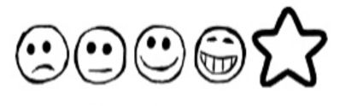
Friday 22nd January 2021. Sayeeda’s Diary

Can I use my own ideas to write an entry in Sayeeda’s diary?
Can I use my sounds to spell my words?

Dear Diary,

Sayeeda

