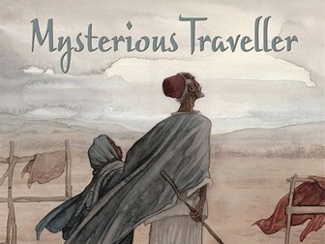
Questions about Mysterious Traveller

Read page 7

What puzzles Issa about the camel?
What two different ways does Issa try to calm the camel?

Read page 9

Why do you think that the camel was reluctant to leave the wall of the rock?
How do you think Issa felt when he found the baby? What words tell you?

Read page 10

What clues are there about the baby’s background?
Who do you think Issa is talking to when he looks at the sky?

Read pages 11 and 12

Why did Issa not return Mariama to her family?
What skills does she learn which are useful for a guide? (Name 3)

Read page 13

What signs does Mariama spot which tells her that Issa is going blind?
Why is this particularly a problem for Issa?

Read pages 15 and 16

What does Issa believe God’s plan was for him? Did he always think this way? Explain your answer.
How do Issa and Mariama work together to guide travellers?

Now think about your reading as a whole

What mysteries have been solved so far? What mysteries are still to be solved? What do you think will happen next?

