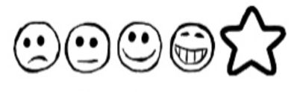
Thursday 21st January 2021 My Treasure Chest

Can I use my own ideas to write words?
Can I use my sounds to spell my words?
Can I write a list?
Draw a picture here

__________________________________________________________________________________________________________________________________________________________________________________________________________________________________________________________________________________________________________________

