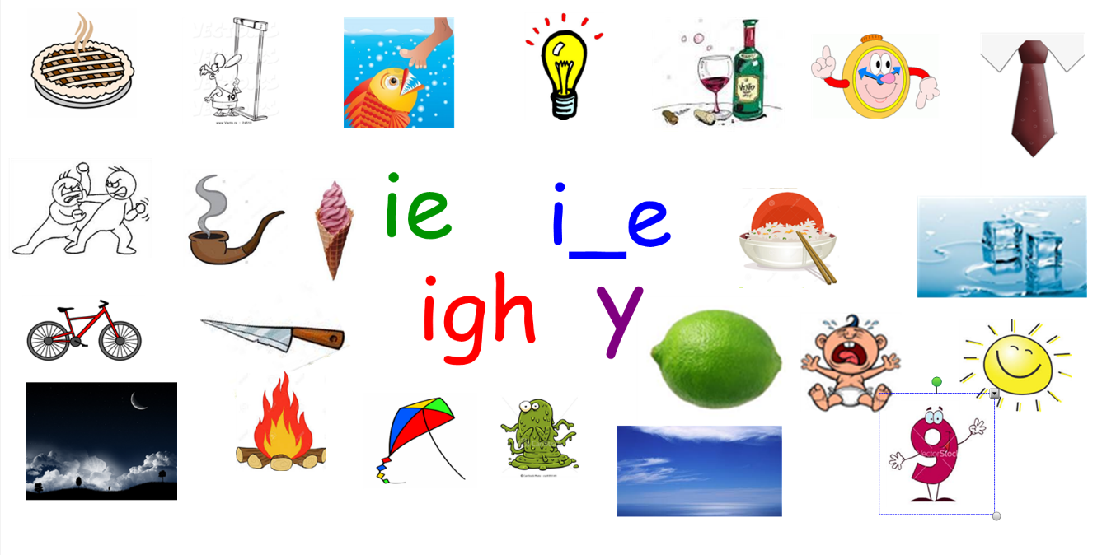

i_e ie igh y
Shine tie

